**A Glossary to support Deaf access to Scientific Journal Systems**

Ronnie Fagundes de Brito1, Vera Lúcia de Souza e Lima 2, Noriko Lúcia Sabanai ³

1 Coordenação de Articulação, Geração e Aplicação de Tecnologia, Instituto Brasileiro de Informação em Ciência e Tecnologia, Brasília, Brasil.

2 Departamento de Engenharia Civil, Centro Federal de Educação Tecnológica de Minas Gerais, Belo Horizonte, Brasil.

³ Secretaria de Estado de Educação do Distrito Federal, Brasília, Brasil.

**Abstract**

This research presents a proposal for structuring a Bilingual Glossary (Brazilian Sign Language / Brazilian Portuguese) of terminology related to scientific communication. And also, demonstrates its application in the development of an user interface that enables deaf accessibility to Open Journal Systems, a software widely used in the publication of Scientific Journals.

Deaf representativeness in the digital environment is a constant challenge to be overcome by the information society in which we live. Sign language, one of the communication means used by deaf people, have benefited from the ability to communicate via video and also written notations which may be more easily represented in digital media.

In this scenario, the development of information systems that present sign languages as the main mean of communication in their interfaces is a determining factor for the affirmation of Deaf`s linguistic rights.

One of the problematic issues that Deaf people face is the scarcity of terminological lexicon in sign language, in the case of Brazil, Libras (Língua Brasileira de Sinais). According to Lima (2014), the lack of technical terms in different disciplines makes access to knowledge inefficient, discouraging them, for example, from reaching higher education.

In the proposed glossary, a term will be represented in three different ways: (1) Portuguese in written form; (2) Video of the sign in Libras, (3) Libras in written form. Signwriting (SUTTON 2009; BARRETO 2015) will be used for Libras writing. This form of writing is derived from a notation for recording dance movements, and has been adapted for recording movements and gestures of sign languages, becoming increasingly popular with deaf community and used from their literacy learning to scholarly communication.

In the Open Journal Systems interface, illustrated in figure 1, the signs in Libras will be presented using Signwriting, where an interaction model, to be developed, will allow access to the record in the glossary of each term or phrase.

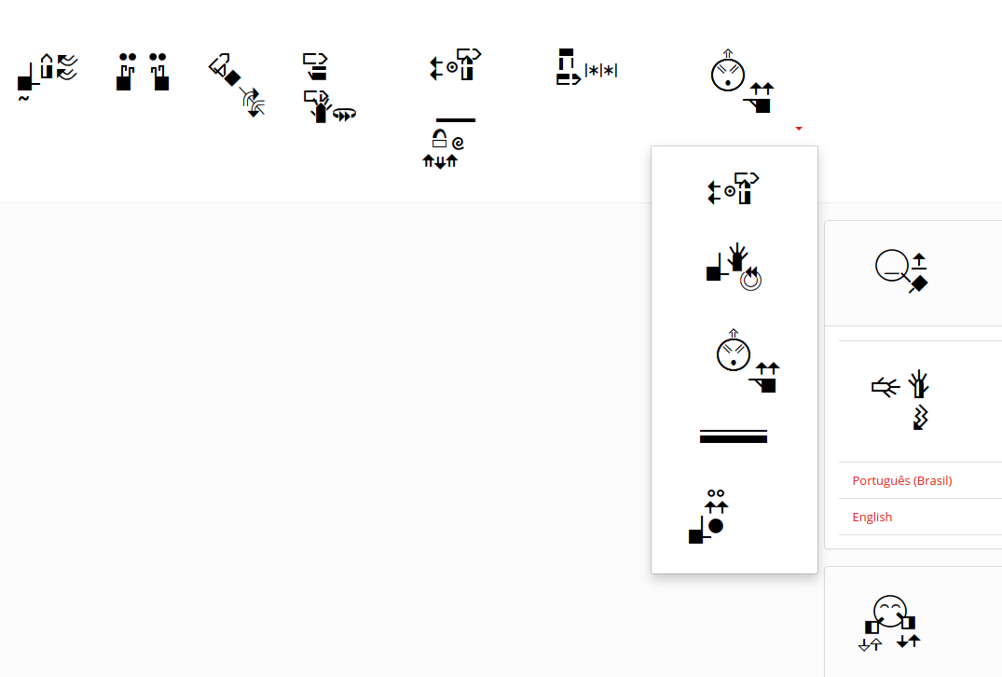

Figure 1: OJS User Interface  
Source: <http://swojs.ibict.br/ojs/>

In addition to terminological development, there is also a challenge regarding the presentation of signs on the software interface, given that Signwriting occupies more space than the characters of the Latin alphabet.

This study is expected to expand access to scientific and technological information for the Deaf, and also to offer a tool for learning Signwriting.

The research has a multidisciplinary character, proper to Terminology, aiming at the production of glossaries in the scientific, technological, linguistic, artistic and cultural areas. The theoretical assumptions used were related to Lexicology and Terminology: Lima (2014) among others, aiming at the production of Bilingual Terminological Glossaries (Brazilian Portuguese / Brazilian Sign Language). Research in the area of Signwriting: Barreto (2015) and typological functional linguistics, such as: Aikhenvald (2008), Brito (1995, 2003), Dixon (2010), Felipe (2001), Lillo-Martin, D.; Klima (1990), Meir, I. et al. (2006), Quadros (1999, 2003), Quadros; Karnopp, (2001), Schembri (2003), Stokoe (1960) etc.

Finally, it is understood that Sign Language is the main Assistive Technology that Deaf need.

This work has the support of CNPq and FINEP (Edital Viver Sem Limites / 2015)

**Keywords:** Brazilian Sign Language, Deaf Accessibility, Scientific Communication, Open Journal Systems, Signwriting.

**References**

AIKHENVALD, A. Y. Classifiers: a typology of noun categorization devices. New York: Oxford University Press, 2008.

BARRETO, M. Escrita de sinais sem mistérios. Salvador, v.1: Libras Escrita, 2015.

BRITO, L. F. Por uma gramática de línguas de sinais. Rio de Janeiro: Tempo Brasileiro: UFRJ, 1995.

______. Língua brasileira de sinais – LIBRAS. In: BRASIL, Secretaria de Educação Especial. Língua Brasileira de Sinais/ organizado por Lucinda F. Brito Et. AL. Brasília: SEESP, 1997. VIII. (série Atualidades Pedagógicas, n.4). p. 19-61. LIDDELL, S. K. Grammar, gesture, and meaning in American Sign Language. New York: Cambridge University Press, 2003.

DIXON, R. M. W. Basic linguistic theory: grammatical topics. New York: Oxford University press, v. 1, 2010.

FELIPE, T. Libras em contexto: curso básico, livro do estudante cursista. Brasília: Programa Nacional de Apoio à Educação dos Surdos, MEC; SEESP, 2001.

LIMA, V. L. de S. Língua de sinais [manuscrito]: proposta terminológica para a área de desenho arquitetônico. Tese (doutorado) - Universidade Federal de Minas Gerais, Faculdade de Letras. Belo Horizonte, Minas Gerais. 2014

LILLO-MARTIN, D.; KLIMA, E. E. Pointing out differences: ASL pronouns in syntactic theory. In Theoretical issues in sign language research, V. 1: Linguistics, eds. Susan D. Fischer and Patricia Siple, 191-210, Chicago: University of Chicago Press, 1990.

MEIR, I. et al. Re-Thinking sign language verb classes: the body as subject. In: QUADROS, R. M. de; VASCONCELLOS, M. L. B. de (Org). Questões teóricas das pesquisas em línguas de sinais. TISLR 9º THEORETCAL ISSUES IN SIGN LANGUAGE RESEARCH CONFERENCE. Florianópolis, SC: Editora Arara Azul, 2006. p. 82-101.

QUADROS, R. M. de. Phrase structure of Brazilian Sign Language. 1999. Tese de Doutorado. Pontifícia Universidade Católica do Rio Grande do Sul. Porto Alegre. 1999.

______. Phrase structure of Brazilian Sign Language. In: Cross-linguistic perspectives in sign language research. Selected papers from TISLR 2000. Signum Press: Hamburg. 2003. p.141-162.

QUADROS, R. M. de; KARNOPP, L. B. Língua de sinais brasileira: estudos lingüísticos. Porto Alegre: Artes Médicas, 2004. SANDLER, W.; LILLO-MARTIN, D. Natural sign languages. In: ARONOFF, M.; REES-MILLER, J. (Eds.). Handbook of linguistics. 2001. pp. 533-562.

SCHEMBRI, A. The syntax and morphology of classifiers in Sign Language: rething ‘classifiers’ in signed languages. In: EMMOREY, K. Perspectives on classifier construction in sign languages. Mahwah, New Jersey: Lawrence Erbaum Associates, Publishers, 2003. P. 03-34.

STOKOE, W. Sign Language structure: an outline of the visual communication systems of the american deaf. Studies in linguistics: occasional papers (Nº 8). Buffalo: Dept. of Anthropology and Linguistics, University of Buffalo, 1960.

SUTTON V. SignWriting: as línguas gestuais são línguas escritas! Manual 1: Noções básicas sobre SignWriting. Tradução de Rafaela Cota Silva. 2009.